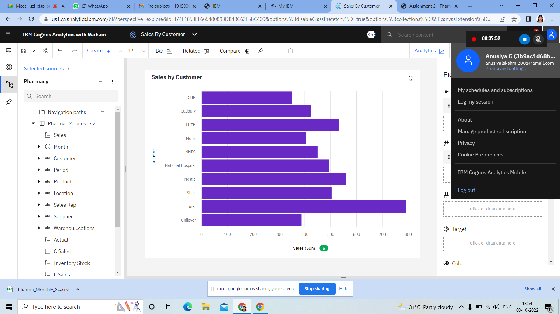

https://us1.ca.analytics.ibm.com/bi/?perspective=explore&pathRef=.my_folders%2FSales%2BBy%2BCustomer&subView=model000001839e02b542_00000004

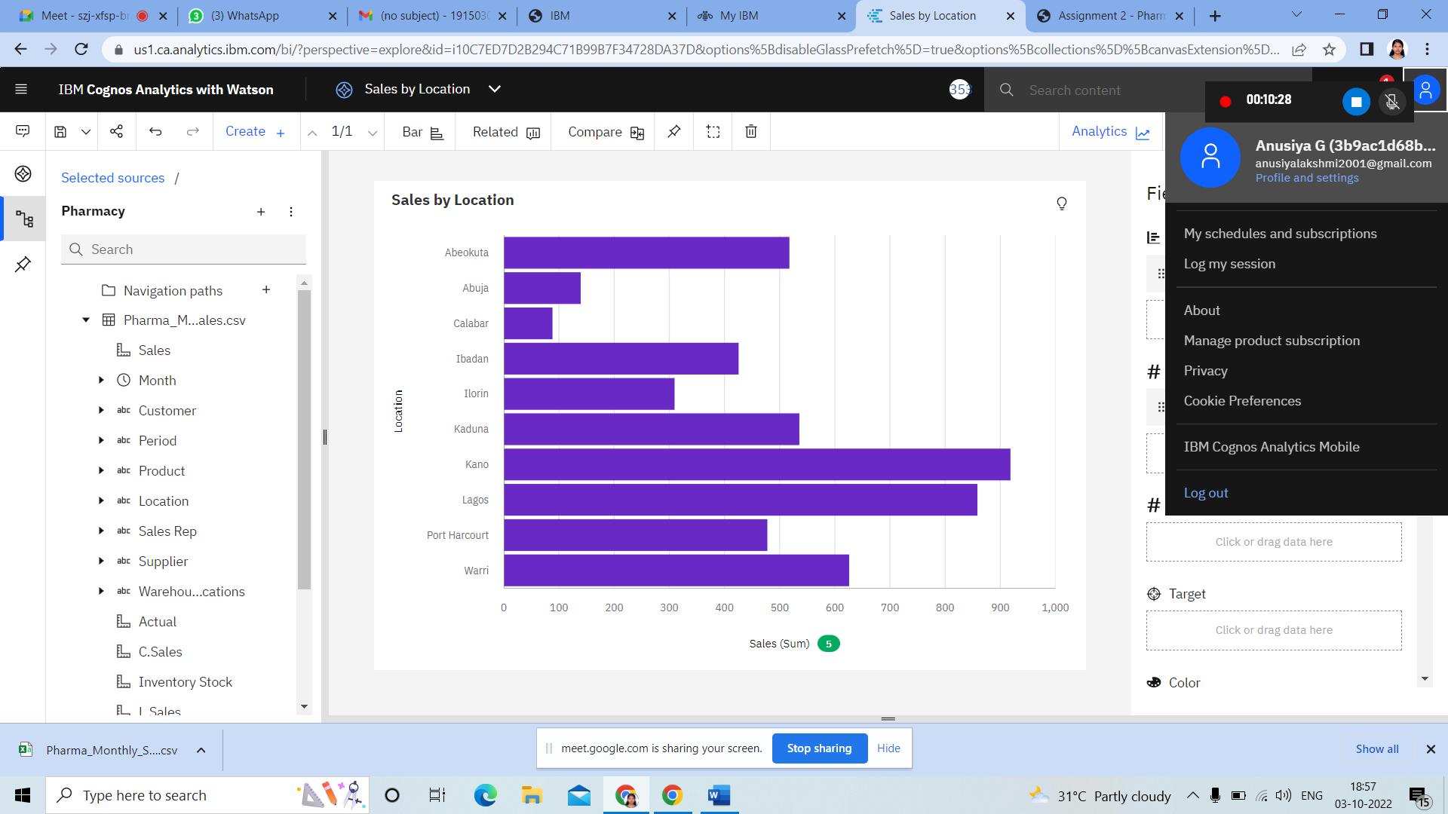

https://us1.ca.analytics.ibm.com/bi/?perspective=explore&pathRef=.my_folders%2FSales%2Bby%2BLocation&subView=model000001839e02b542_00000004

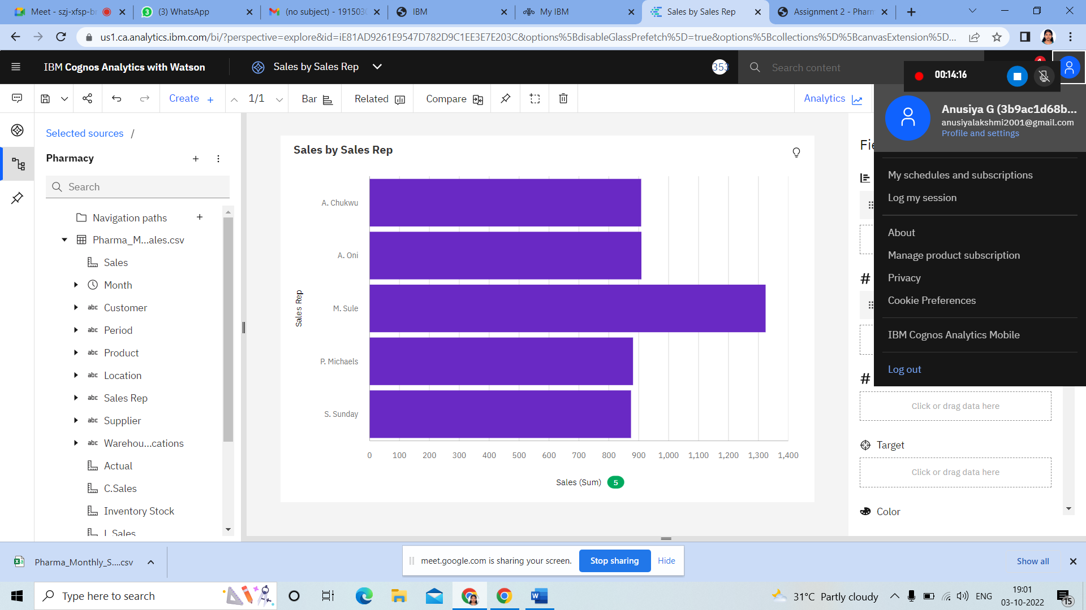

https://us1.ca.analytics.ibm.com/bi/?perspective=explore&pathRef=.my_folders%2FSales%2Bby%2BSales%2BRep&subView=model000001839e02b542_00000004

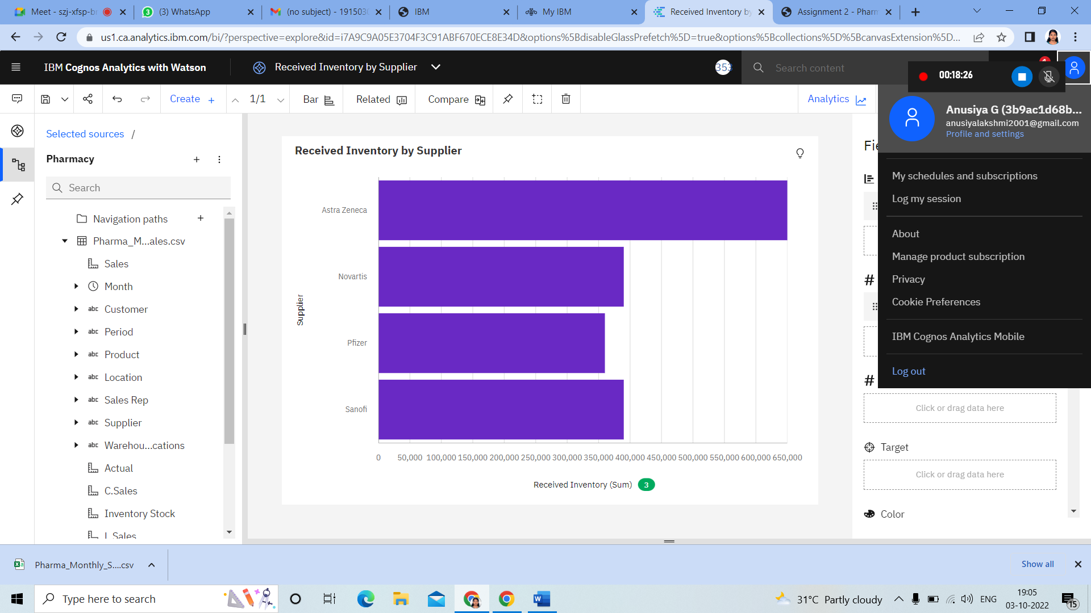

https://us1.ca.analytics.ibm.com/bi/?perspective=explore&pathRef=.my_folders%2FReceived%2BInventory%2Bby%2BSupplier&subView=model000001839e0d1ad6_00000000

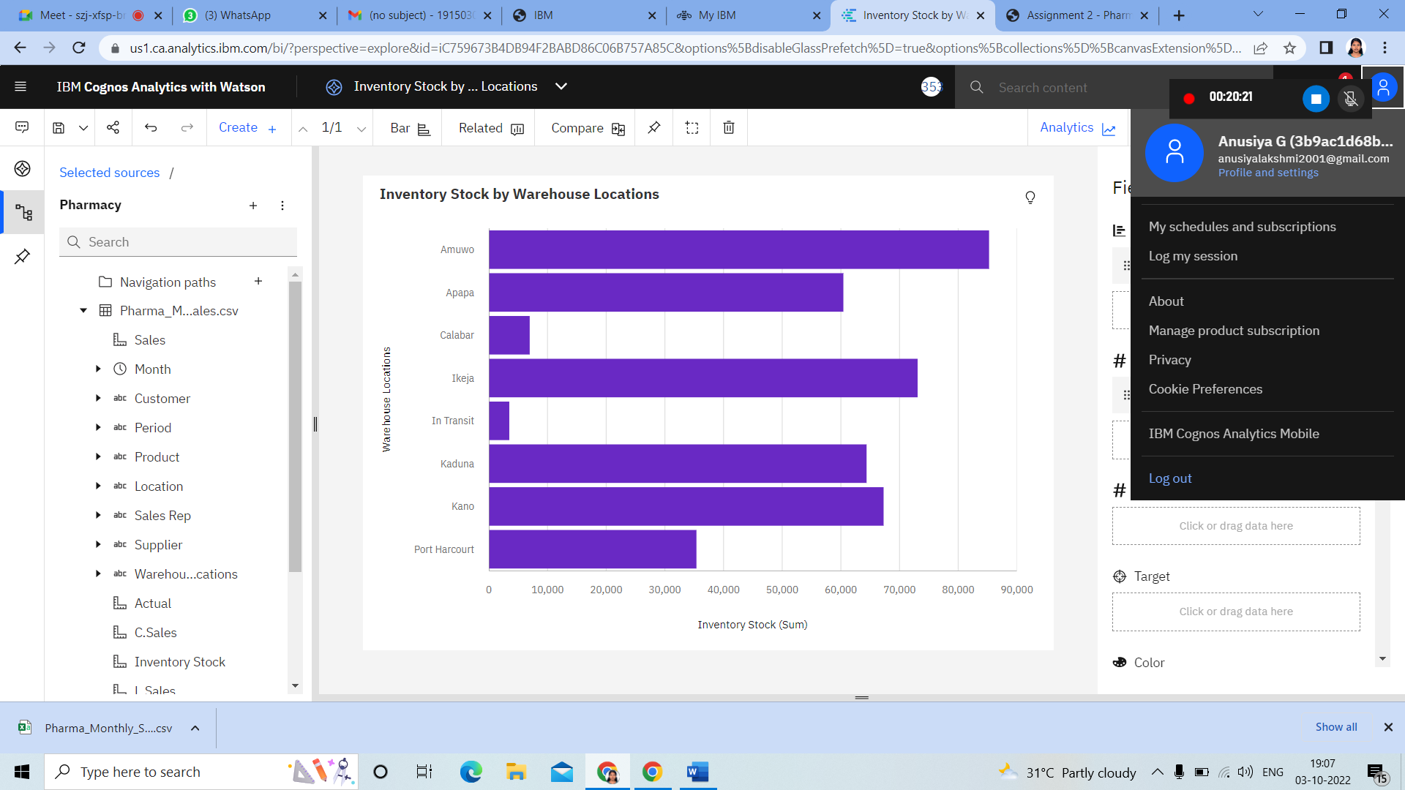

https://us1.ca.analytics.ibm.com/bi/?perspective=explore&pathRef=.my_folders%2FInventory%2BStock%2Bby%2BWarehouse%2BLocations&subView=model000001839e0d1ad6_00000000

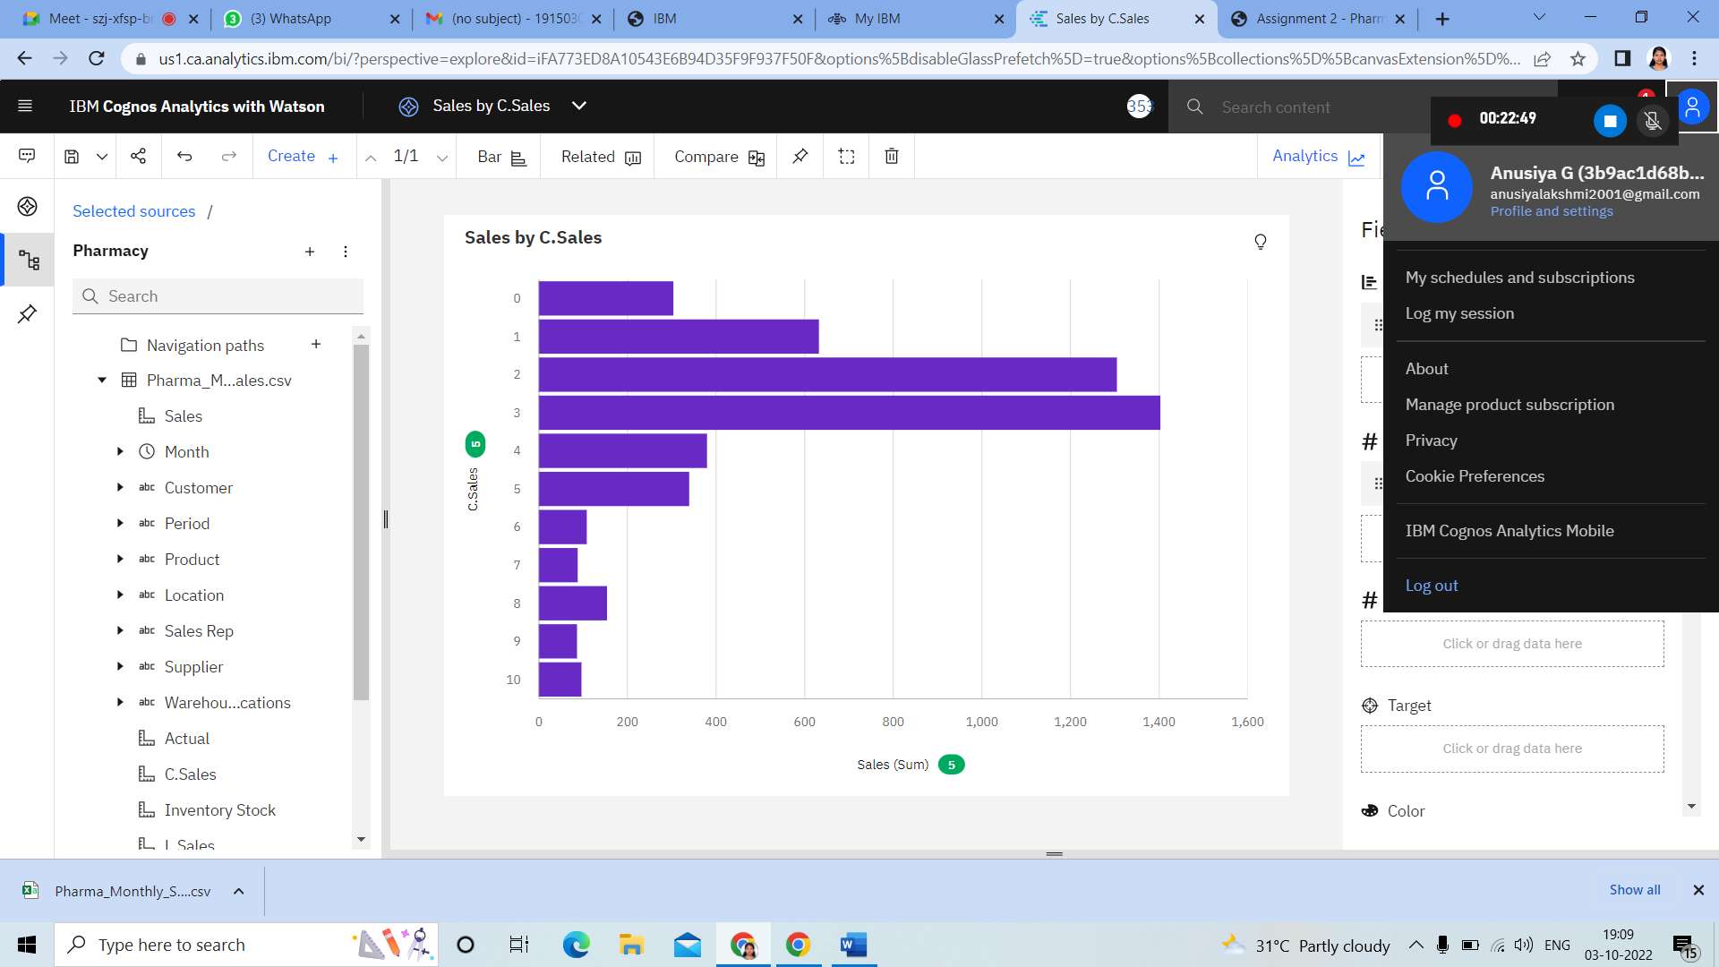

<https://us1.ca.analytics.ibm.com/bi/?perspective=explore&pathRef=.my_folders%2FSales%2Bby%2BC.Sales&subView=model000001839e0d1ad6_00000000>

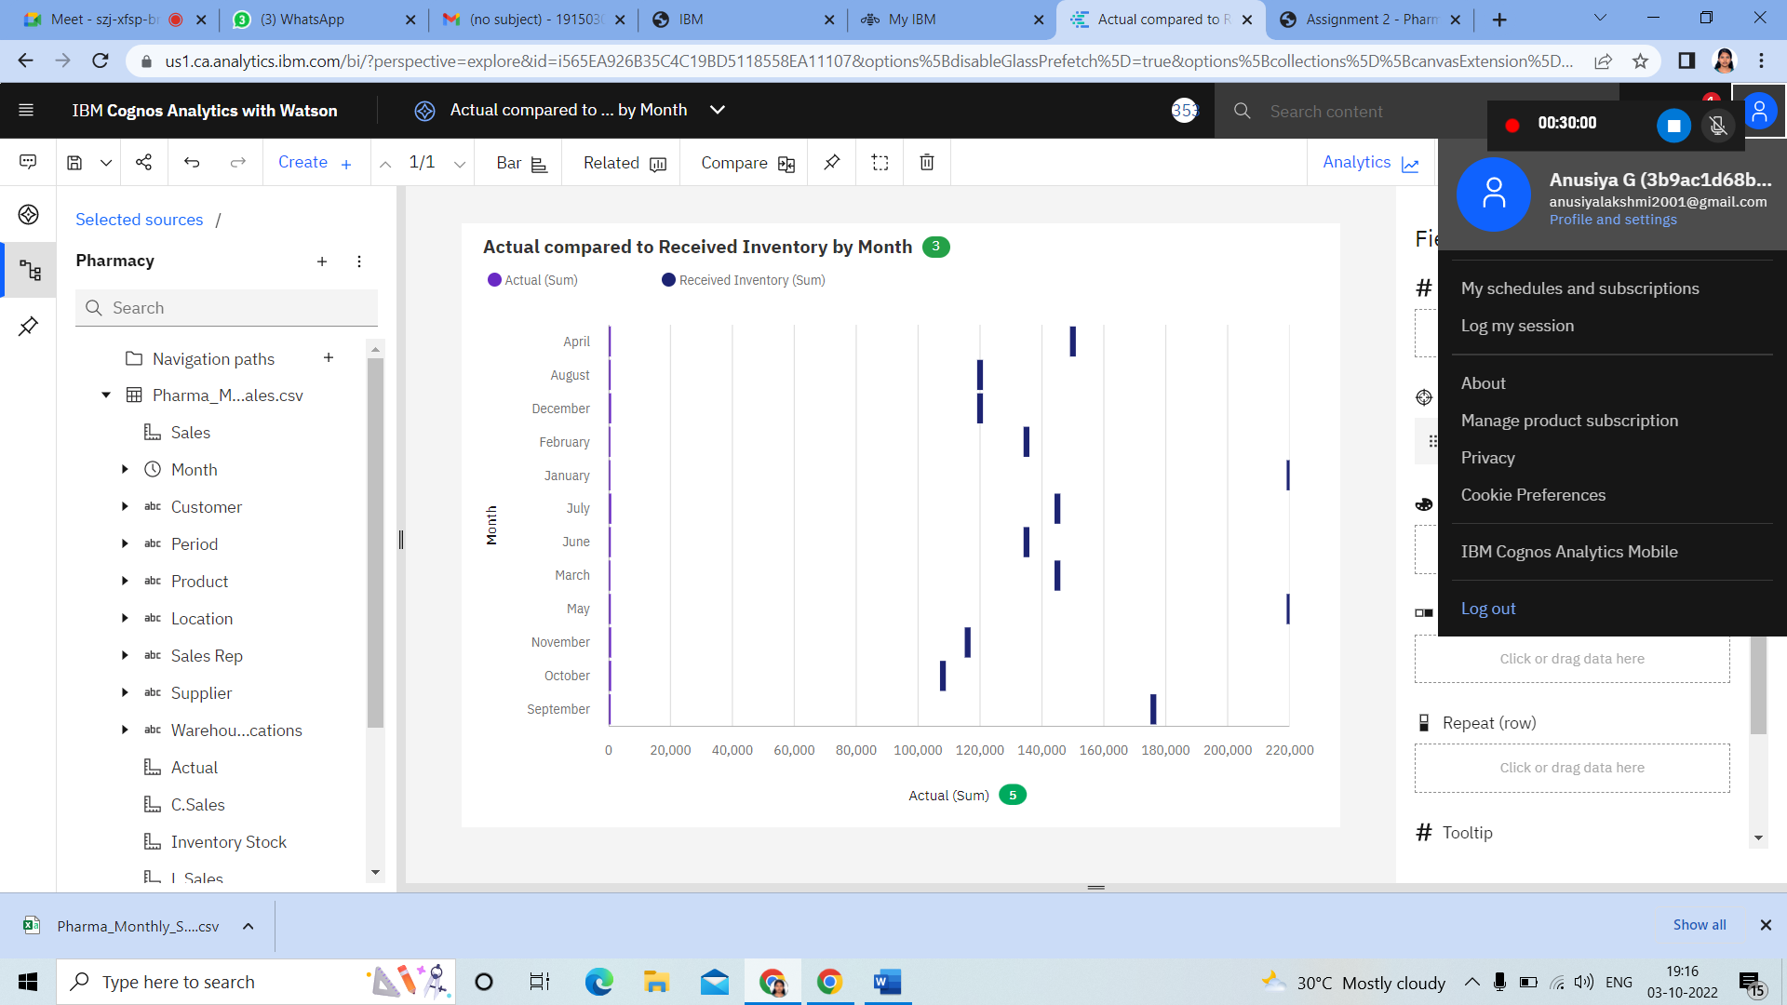

<https://us1.ca.analytics.ibm.com/bi/?perspective=explore&pathRef=.my_folders%2FActual%2Bcompared%2Bto%2BReceived%2BInventory%2Bby%2BMonth&subView=model000001839e0d1ad6_00000000>

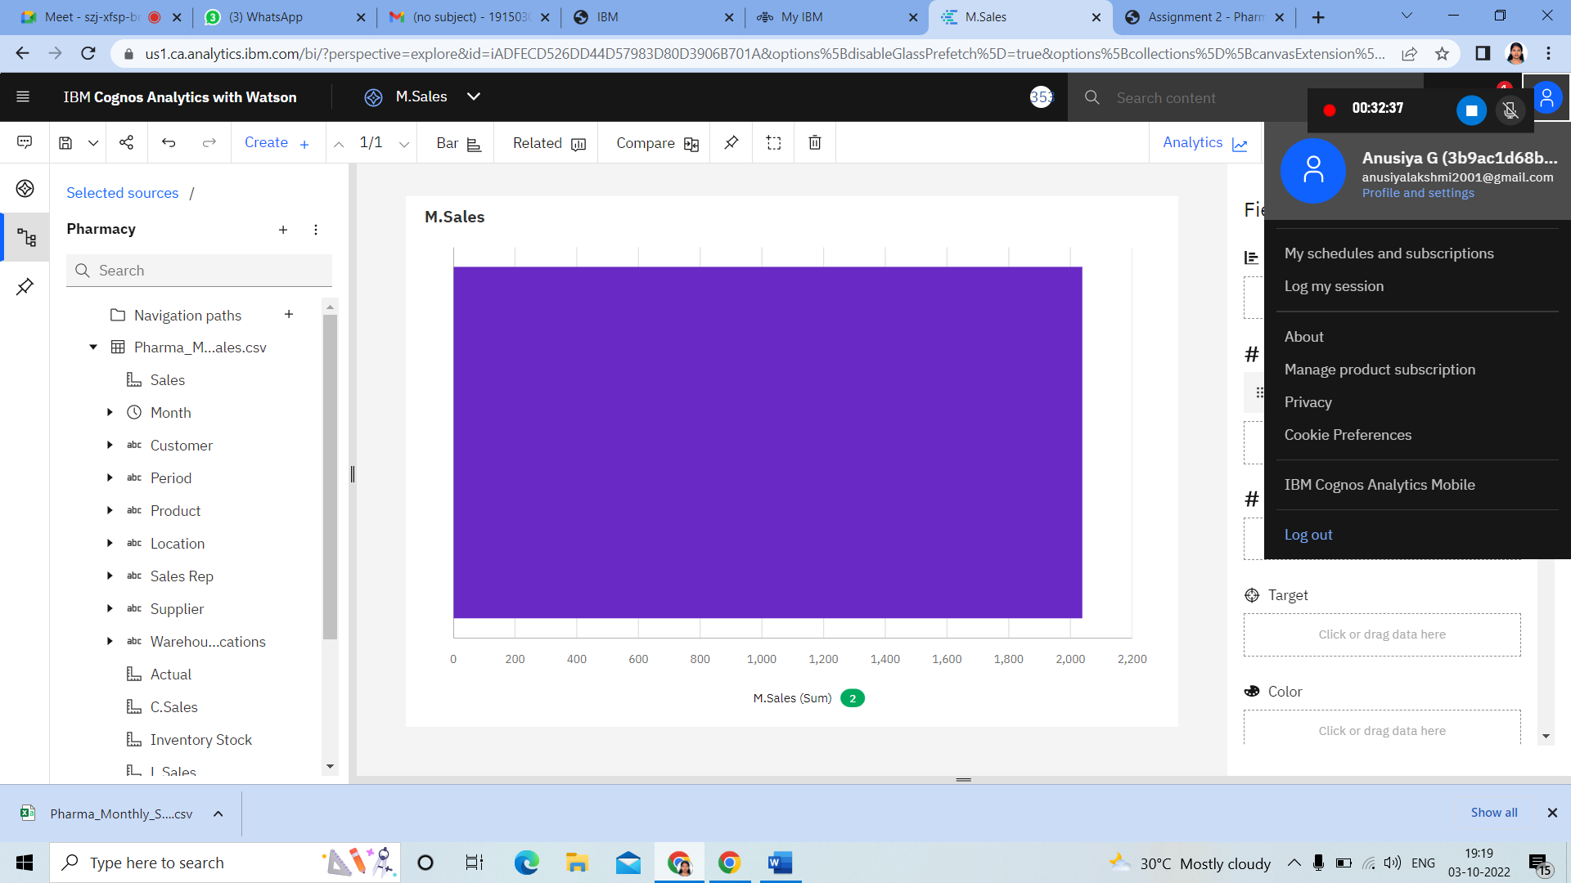

https://us1.ca.analytics.ibm.com/bi/?perspective=explore&pathRef=.my_folders%2FM.Sales&subView=model000001839e0d1ad6_00000000

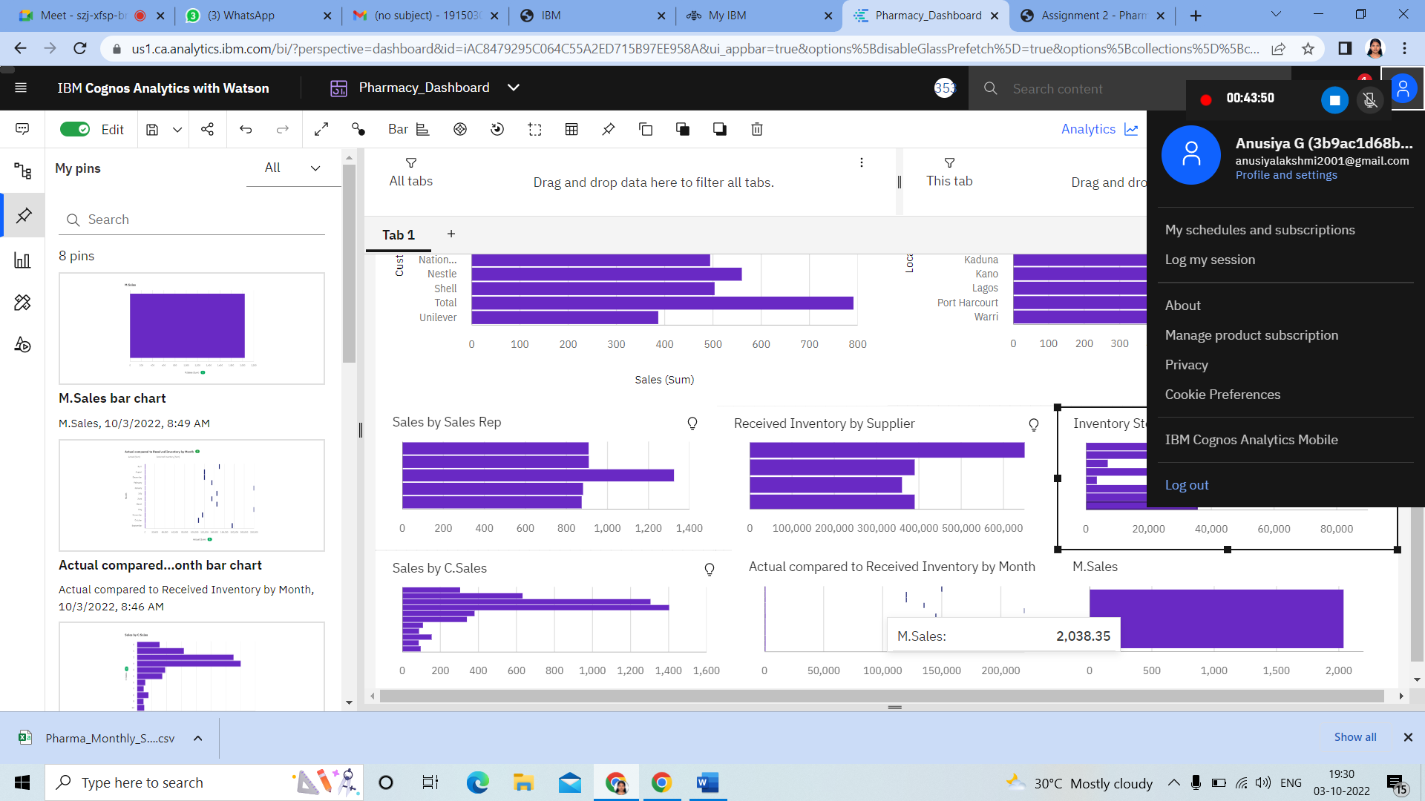

https://us1.ca.analytics.ibm.com/bi/?perspective=dashboard&pathRef=.my_folders%2FPharmacy_Dashboard&action=view&mode=dashboard&subView=model000001839e1c7a92_00000000